2019 PHRF SPRING / SUMMER SERIES
PHRF Racing: April 28, 2019 (Preliminary Results)
Race 7: Skipper’s meeting started at 12:00 AM. We had a nice group of participants (8 boats). There were 3 Capri’s (club boats) racing today. The weather started out with sunny skies and a lite breeze out of the SSE. Before we could finish setting the course for a pursuit race, the breeze clocked to the SSW. At this point we decide to suspend the pursuit race and proceed with a regular PHRF 9single start line) less the flags. Everyone adjusted well, including the race committee. Race 7 started in the eastern part of Boca Ciega Bay and went west to Mark 16 (taken to port) with a long reach to Marker 14 & 15 (taken to port) and a run to the Committee Boat and Drop Mark. The course was approximately 3.1 nm. Mark Rother and crew (Greg Graham and Suzanne Boohar) in Godzilla reached the windward mark in 20 minutes with James Masson, single handling a (Capris 16.5) hot on his heals. Race 7 was completed in 56 minutes with first to finish going to Mark Rother in 44 minutes.
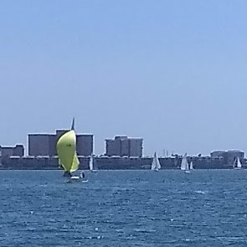
Today’s conditions favored the smaller lighter boats. I believe that everyone had a good time.
Corrected Finish “Preliminary”:
1st James Masson Capri 16.5
2nd Doug Fuller Capri 22
3rd Mark Rother Impulse 21
4th Stanislov Capris 16.5
5th Marc Fortune Ben First 235
6th Sharon Vreeland Capris 16.5
7th Dave Roberts Catalina 31
8th Sharon Grasmehr Ericson 324
Race 8: The course configuration for Race 8 remained the same. By this time the breeze was steady, and all 8 boats started. The start line became crowded with 7 of the 8 boats jockeying for position. No collisions, just a good tight start. Mark Rother and crew were first to the windward mark in 22 minutes. This time was 2 minutes slower than Race 7; however, that is still a consistent performance. Talk about good racing, Race 7 took 44 minutes and 50 seconds to complete. Race 8 was completed in 43 minutes and 33 seconds. The difference was 1 min and 17 seconds faster in Race 8.
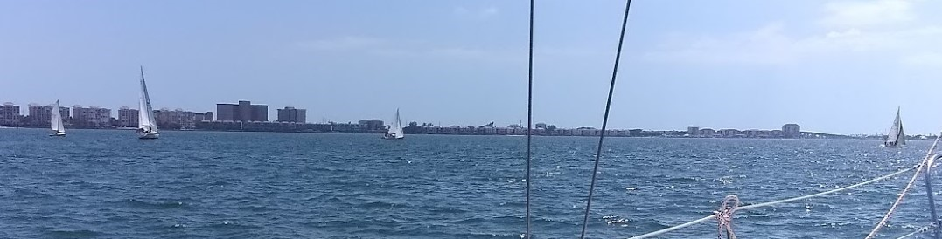
Start of Race 8 (port side of Committee Boat)
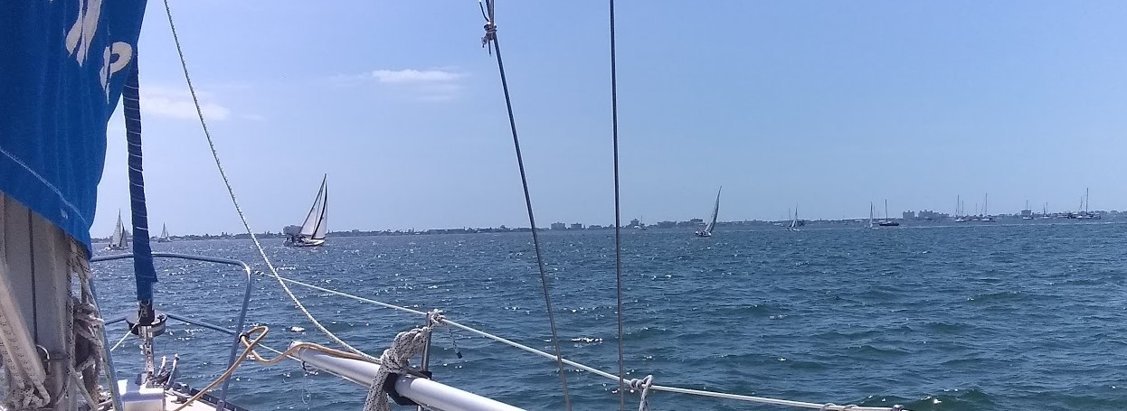
Start of Race 8 (starboard side of Committee Boat)
Corrected Finish “Preliminary”:
1st James Masson Capri 16.5
2nd Mark Rother Impulse 21
3rd Stanislov Capris 16.5
4th Marc Fortune Ben First 235
5th Doug Fuller Capri 22
6th David Roberts Catalina 31
7th Sharon Grasmehr Ericson 323
8th Sharon Vreeland Capri 16.5
For the most part the racing has been very good. Lighter air days go to the smaller one design racing boats. Heavier air days favor the bigger cruisers. We have had some new members participate in the racing as well as race committee work. Participation is up about 30% over last year. I have heard about 1 collision between 2 cruisers. The offending boat did a 720. Just remember whenever possible avoid contact.
The overall standings have not yet be computed due to technical difficulties on my part. Hopefully, they will be posted by the Board Meeting this coming Monday.
Sunday, March 17, 2019 - Races 5 & 6
PHRF Racing: March 17, 2019. (Preliminary Results)
Race 5: Skipper’s meeting started at 11:00 AM. We had a nice group of participants (11 boats). We have not had that many boats in quite a while. There were 3 Capri’s (club boats) racing today. That would be enough to muster up a separate class for one design! Perhaps next time. The weather started out a little on the cloudy side with light and variable winds out of the NNE at 5-7 knots. Todays course covered a large portion of Boca Ciega Bay. With the fluky air, it required 22 minutes for the first boat to round the windward mark. James Masson, single handing a club Capri 16.5, was first around. Jim Masson and the Capri 16.5 built up a significant lead that saw the Capri 16.5 Finishing 1st in Race 5.
Mark Rother and crew (Greg Graham) on Godzilla had their work cut out as they battled back and finally caught Masson in the Capri 16.5. After time correction Godzilla corrected out to 5th place. The fluky air played havoc with entire fleet.
Dave Roberts on “Legacy” (Catalina 31) finished 5th and corrected out to 2nd Place.
Marc Fortune on “Echo” (Beneteau First 235) finished 3rd and corrected out to 3rd. Way to go Marc, great job. See all of the results below.
Legacy – Echo - Seaduceme
Total time required to complete Race 5 was 1 hour 57 minutes. There were 2 DNF’s and 1 DNS.
Race 6: The course configuration for Race 6 was shortened to a windward / Leeward course. By this time the breeze was beginning to freshen and had clocked from the NNE to the E. The course was adjusted accordingly. A few pics of the Start.
Shenandoah - Claudia Gail – Moonshine – Legacy - Echo
Race 6 was underway at 2:50 PM. The breeze was fresh 8 – 10 knots out of the East.
Capri 16.5 – Legacy - Claudia Gail - Capri 16.5
A good time was had at the Club House after the race. BCYC provided the beer. Sorry, “Green” beer was not available! Hope to see more BCYC boats out and Racing. Race Committee: Steve Conn, Tony Angel, Jan and Garth Reynolds.
Overall Results to Date
 | Sail | Boat | Skipper | Type | Total | Pursuit | Pursuit | PHRF | PHRF | PHRF | PHRF
1 | 2 | 3 | 4 | 5 | 6
1 | 115 | Legacy | Roberts, Dave | Catalina 31 | 10 | 5 | 1 | 1 | 1 | 2 | 4*
2 | 117 | Echo | Fortune, Marc | Beneteau First 235 | 16 | 3 | 5* | 3 | 4 | 3 | 3
3 | 683 | Seaduceme | Fuller, Doug | Capri 22 | 18 | 1 | 4 | 4 | 7* | 7 | 2
4 | 651 | Moonshine | Grasmehr, Sharon | Ericson 323 | 20 | 4 | 3 | 2 | 5 | 6 | 7*
5 | 889 | Godzilla | Rother, Mark | Impulse 21 | 21 | 2 | 2 | 9*DNF | 6 | 5 | 6
6 | 6 | #6 | Masson, James | Capri 16.5 | 27 | 8 DNC | 8 DNC | 9*DNC | 9 DNC | 1 | 1
7 | 58 | Claudia Gayle | Hendricks ,Elizabeth | Nonsuch | 34 | 8 DNC | 8 DNC | 7 | 3 | 11*DNF | 8
8 | 3 | #3 | Pilert, Mike | Capri 16.5 | 34 | 8 DNC | 8 DNC | 9*DNC | 9 DNC | 4 | 5
9 | 5 |  | Russian, Stanislov | Capri 16.5 | 35 | 8 DNC | 8 DNC | 6 | 2 | 11 DNF | 12*DNF
10 | 135 | Fanta-Sea | Calvillo, Robert | Albin 28 | 41 | 8 DNC | 8 DNC | 5 | 9 DNS | 11 DNS | 12*DNS
11 | 206 | Koinonia II | Reynolds, Garth | Tartan 33 | 41 | 6 | 6 | 9 DNC | 9 DNC | 11 DNC | 12*DNC
12 | 266 | The Other Way | Duffy, Leslie &. | Catalina 22 sk | 44 | 7 | 8 DNF | 9 DNC | 9 DNC | 11 DNC | 12*DNC
13 | 000 | Shenandoah | Demetrius, Kanelltsas | Ben Oc 370 | 45 | 8 DNC | 8 DNC | 9 DNC | 9 DNC | 11 DNC | 12*DNF
The overall standings are pretty tight with a spread of 11 points among the top five boats at this time. For those of you contemplating a little racing, jump in and join the fun. You will learn more about your boat and your sailing skills by watching what your friends are doing.
If you have any photos of the racers please send them in so they can be posted.
Race Name=PHRF 6
Wind Speed: 6-8 Wind Direction: E
Date: 03/17/19 Start Time: 14:50:00 Distance: 0.0nm
Pos |  |  | Sail | Boat | Skipper |  |  | Type | Finish | Elapsed | Corrected | Score
1 |  |  | 6 | #6 | Masson, James |  |  | Capri 16.5 | 15:15:07 | 00:25:07 | 00:21:42 | 1
2 |  |  | 683 | Seaduceme | Fuller, Doug |  |  | Capri 22 | 15:16:14 | 00:26:14 | 00:23:25 | 2
3 |  |  | 117 | Echo | Fortune, Marc |  |  | Beneteau First 235 | 15:16:19 | 00:26:19 | 00:23:30 | 3
4 |  |  | 115 | Legacy | Roberts, Dave |  |  | Catalina 31 | 15:17:45 | 00:27:45 | 00:23:55 | 4
5 |  |  | 3 | #3 | Pilert, Mike |  |  | Capri 16.5 | 15:18:07 | 00:28:07 | 00:24:18 | 5
6 |  |  | 889 | Godzilla | Rother, Mark |  |  | Impulse 21 | 15:18:08 | 00:28:08 | 00:26:59 | 6
7 |  |  | 651 | Moonshine | Grasmehr, Sharon |  |  | Ericson 323 | 15:23:00 | 00:33:00 | 00:30:41 | 7
8 |  |  | 58 | Claudia Gayle | Hendricks, Elizabeth |  |  | Nonsuch | 15:37:30 | 00:47:30 | 00:41:24 | 8
DNF |  |  | 5 |  | Russian, Stanislov |  |  | Capri 16.5 |  |  |  | 12
DNF |  |  | 000 | Shenandoah | Kanelltsas, Demetrius |  |  | Ben Oc 370 |  |  |  | 12
DNS |  |  | 135 | Fanta-Sea | Calvillo, Robert |  |  | Albin 28 |  |  |  | 12
Race Name=PHRF 5
Wind Speed: 3-5 Wind Direction:
Date: 03/17/19 Start Time: 12:30:00 Distance: 0.0nm
Pos | Sail | Boat | Skipper |  |  | Type | Finish | Elapsed | Corrected | Score
1 | 6 | #6 | Masson, James |  |  | Capri 16.5 | 14:08:22 | 01:38:22 | 01:25:00 | 1
2 | 115 | Legacy | Roberts, Dave |  |  | Catalina 31 | 14:12:02 | 01:42:02 | 01:27:58 | 2
3 | 117 | Echo | Fortune, Marc |  |  | Ben First 235 | 14:08:35 | 01:38:35 | 01:28:01 | 3
4 | 3 | #3 | Pilert, Mike |  |  | Capri 16.5 | 14:11:56 | 01:41:56 | 01:28:05 | 4
5 | 889 | Godzilla | Rother, Mark |  |  | Impulse 21 | 14:04:10 | 01:34:10 | 01:30:18 | 5
6 | 651 | Moonshine | Grasmehr, Sharon |  |  | Ericson 323 | 14:14:53 | 01:44:53 | 01:37:30 | 6
7 | 683 | Seaduceme | Fuller, Doug |  |  | Capri 22 | 14:27:00 | 01:57:00 | 01:44:28 | 7
DNF | 5 |  | Russian, Stanislov |  |  | Capri 16.5 |  |  |  | 11
DNF | 58 | Claudia Gayle | Hendricks, Elizabeth |  |  | Nonsuch |  |  |  | 11
DNS | 135 | Fanta-Sea | Calvillo, Robert |  |  | Albin 28 |  |  |  | 11

Sunday, Feb 17, 2019 - Races 1, 2, 3 & 4
Race Format: PHRF
 | Bow | Sail | Boat | Skipper | PHRF | Club | Type | Total | Purs 1 | Pur 2 | PHRF 3 | PHRF 4
1 | 2 | 115 | Legacy | Roberts,Dave | 262 | BCYC | Catalina 31 | 8 | 5 | 1 | 1 | 1
2 | 10 | 651 | Moonshine | Grasmehr,Sharon | 203 | BCYC | Ericson 323 | 14 | 4 | 3 | 2 | 5
3 | 5 | 117 | Echo | Fortune,Marc | 234 |  | Ben First 235 | 15 | 3 | 5 | 3 | 4
4 | 6 | 683 | Seaduceme | Fuller,Doug | 234 | BCYC | Capri 22 | 16 | 1 | 4 | 4 | 7
5 | 11 | 889 | Godzilla | Rother,Mark | 180 | BCYC | Impulse 21 | 19 | 2 | 2 | 9 DNF | 6
6 | 25 | 5 | Capri 16.5 | Stanislov Yefimov | 260 | BCYC | Capri 16.5 | 24 | 8 DNC | 8 DNC | 6 | 2
7 | 24 | 58 | Claudia Gayle | Elizabeth Hendricks | 253 | BCYC | Nonsuch | 26 | 8 DNC | 8 DNC | 7 | 3
8 | 7 | 135 | Fanta-Sea | Roberrt Calvillo | 231 | BCYC | Albin 28 | 30 | 8 DNC | 8 DNC | 5 | 9 DNS
9 | 8 | 206 | Koinonia II | Garth Reynolds | 210 | BCYC | Tartan 33 | 30 | 6 | 6 | 9 DNC | 9 DNC
10 | 1 | 266 | The Other Way | Leslie & Joe Duffy | 66 | BCYC | Catalina 22 sk | 33 | 7 | 8 DNF | 9 DNC | 9 DNC
Race Results: 02172019 PHRF Racing Spring Summer Series Boca Ciega Ba1.pdf

Sunday, Feb 10, 2019 - Races 1 & 2
Race Format: PURSUIT
We finally got Races 1 and 2 of the Spring / Summer PHRF Series off, after 2 delays in January. A total of 7 boats came out on a beautiful sunny, warm and breezy day. The wind was out of the East at about 8 and increased with some gusts up to 13 -15 mph. We welcomed 2 new racers to our group (Joe and Leslie Duffy, Catalina 22) and (Sharon Grasmehr, Ericson 323).
The course was 4.7 nm and covered the entire Boca Ciega Bay. Starts commenced at 12:30 pm. A downwind running start was employed in both races.
One of the reaching legs utilized the ICW. Here is a quote from one of our sailors. “My body is reminding me that it has been about two months since I big boat raced at my club. We took first in the first race; despite jockeying for position, in the channel, with the 113 ft motor vessel (we are a 22 ft. Sail boat) Starlight Cruise Dinner Motor vessel. There is some great video that some of the passengers took of us... the second race was uneventful, and we did not finish last.”
There were 2 incidents in the ICW where racers searched for and found shallow water. Since they were racing, they refused tows and got themselves going again. The Race chairman has made a promise not to utilize the ICW in future races.
Order of finish for the Race 1: Race 2:
1. Doug Fuller and crew on Seaduceme 1. David Roberts and crew on Legacy
2. Sharon Grasmehr and crew on Moonshine 2. Mark Rother and crew on Godzilla
3. Mark Fortune and crew on Echo 3. Sharon Grasmehr and crew on Moonshine
Photos coming soon. We are glad that everyone had a good time during the races and afterward.
Race Results: 02102019 BCYC PHRF Race 1 and 2 Results.pdf

BCYC Spring/Summer and Summer Fall Series shall follow the 2013-2016 Racing Rules of Sailing (RRS) as prescribed by US Sailing
- Eligibility & Entry: Racing is open to BCYC Members and guest sailing PHRF rated sailboats.
- Races are held on the Sunday following monthly BCYC member meetings which are held the 3rd Friday of each month
- BCYC Race Starting Sequence (TBD click here)
- BCYC Race Course/Buoy positions on Boca Ciega Bay click here
- 2016 Notice of Race (NOR) click here
In 2016, the Sunday PHRF* Series race classifications were changed from Spinnaker, Non-Spinnaker and Cruising to PHRF A, B and C. The range of PHRF ratings per each class are summarized as follows:
PHRF A: Ratings Ranging from 140 – 219
PHRF B: Ratings Ranging from 220 – 249
PHRF C: Ratings Ranging from 250 – 286
Overall (A,B,C): Ratings Ranging from 140 – 286
Race results for participants in each class and a combined “overall” (PHRF a, b & c) will be posted shortly after each race. Please note the PHRF ratings within each class may need to be adjusted to ensure a minimum number of boats to score each class.
* West Florida Performance Handicap Racing Fleet (WFPHRF)
Having a WFPHRF certificate is a good thing, as it allows you to compete in other racing events in our region with your rating. If you do not have a PHRF Rating from WFPHRF, BCYC Race Committee can provide a PHRF Rating for your participating sailboat.
The West Florida Performance Handicap Racing Fleet (WFPHRF) serves the Florida West Coast from Crystal River to Marco Island and all of the Tampa Bay area. The primary objective of WFPHRF is to establish and maintain an equitable system of handicapping boats for the boats owned or chartered by its members.
WFPHRF Ratings are performance handicaps, based on the speed potential and performance of a boat. To the greatest extent possible, race results and observations of actual races provide the data used to determine and monitor ratings. Ratings are determined by members who serve voluntarily as Handicappers on the Rating Committee.
For additional information click here

